**LABULK 0335 TAP DENSITY TESTER MANUAL**

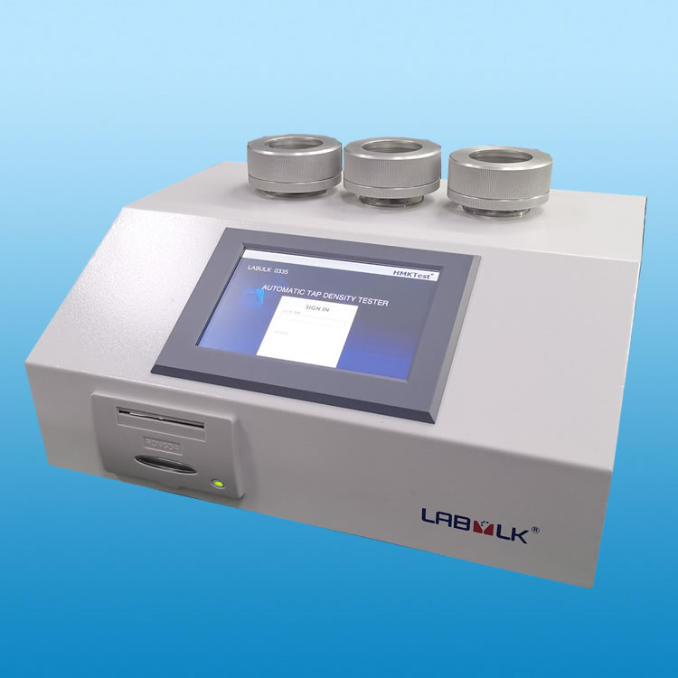

**DANDONG HMKTEST INSTRUMENT CO.,LTD.**

**1.INSTALLATION**

1.1 Install tapping assembly

1.1.1 Take a glass cylinder usually 100mL/250mL, put on the ring pad. Volume of the cylinder is as per standard, please ask HMKTest for suggestions.

1.1.2 Put on Al washer

1.1.3 Put the round pad on bottom of the cylinder

1.1.4 Screw in tight

1.2 Tap height

1.2.1 Two tap height for selection

1.2.2 One is 3mm(popular), the other is 14mm(optional). Use 3mm if standard is not clear or ask HMKTest for suggestions.

1.2.3 Two tapping station are available in order to test together.

1.3 Connection

1.3.1 Connet power cable to LABULK 0335.

1.3.2 If optional balance is purchased, connect balance to LABULK 0335.

**2. LOGIN & PASSWORD**

2.1 Login as Admin

2.1.1 Touch LOGIN NAME-Admin

2.1.2 Touch PASSWORD

2.1.3 Input PASSWORD 3360

2.2 Login as User

2.2.1 Touch LOGIN NAME-Admin

2.2.2 Touch PASSWORD

2.2.3 Input PASSWORD 3000

**3. SETUP**

2.1 Check

2.1.1 Touch Check, observe the status, both should be OK, check connection points if it shows NOK.

2.1.2 If both are OK, continue setup, if NOK persists after check on the connection, please ask HMKTest for suggestions.

2.2 Motor

2.2.1 Touch Motor

2.2.2 MODE. Touch once to show one mode and touch twice to use the other mode.

2.2.3 COUNT. Test by count is popular, here user need to set the number of count. Touch drop-down arrow to select among default count, touch Count to input. This parameter is also involved with standards, if standard not available please ask HMKTest for suggestions.

2.2.4 RPM. It is the speed of the motor, i.e. revolutions per minute. Touch drop-down arrow to select among default rpm, usually 250rpm, touch RPM to input.

2.2.5 TIME. If TIME mode is selected, operator inputs time here, the unit is second.For those that total counts number exceeds 3000, user has to use TIME mode to get desired number.

2.2.6 HEIGHT. Touch once to show one height, touch twice to show the other. It is ONLY to show on the test report for print, the defaulty height is 3mm.

2.3 Sample

2.3.1 NO.Touch to input No of test.

2.3.2 WEIGHT. Touch to input sample weight. If optional balance is purchased, operator can obtain weight in Work-BALANCE as well.

2.3.3 V0. Touch to input volume before tapping.

2.3.4 DATE. Touch to modify the date, it is only open to Admin

**4. Work**

3.1 Touch Work to open.

3.2 V0. It should be input in Sample, if not, input volume before tapping

3.3 START. Touch to start test. LABULK 0335 works and time counts down. The machine stops automatically after test.

3.4 STOP. In case operator wants to stop during working, touch STOP but once restart, the operation works from the beginning.

**5. VOLUME AFTER TAP VF**

Touch VF to input volume after tapping, view parallel and if surface is not levelled, read the top and bottom and input averaged data.

**6. CALCULATION**

5.1 T.D. Touch it to show tapped density.

5.2 C.I. Touch it to show compressibility index.

5.3 H.R. Touch it to show Hausner Ratio.

**7. DATA**

6.1 Touch Data-SAVE to save the current test results. Up to 16 results are saved.

6.2 Touch DEL to delete if login as an Admin

6.3 Touch NEXT to view records

Data is only open to Admin

**8. PRINT**

Touch PRINT to print the rest report.Dot matrix printer gives life record.

1. **MAINTENANCE AND INSTRUCTIONS**

9.1 Put on some glycerol on the end of the screw regulaly.

9.2 Drop some oil on the cylinder holder washer regularly.

9.3 Clean the panel regularly.

9.4 Do not insert finger or something else into the hole.

9.5 Turn off the machine in case it does not perform and restart after a while (20 seconds).